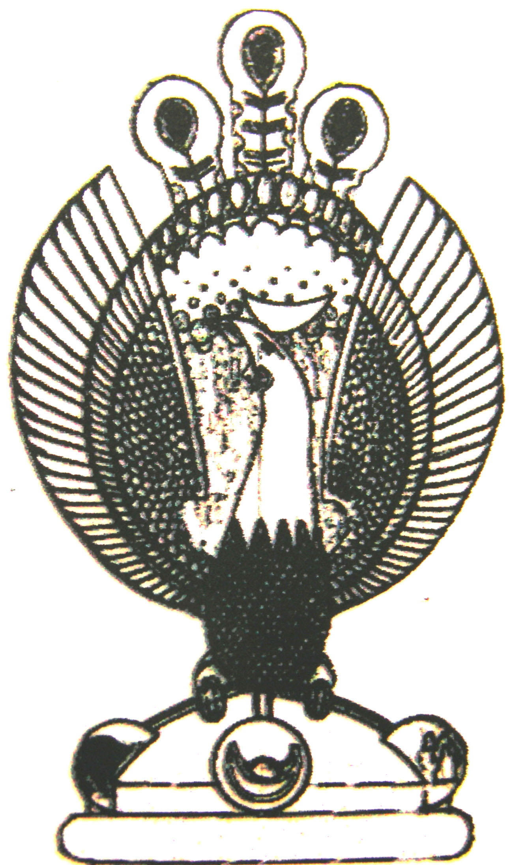

THE HERITAGE

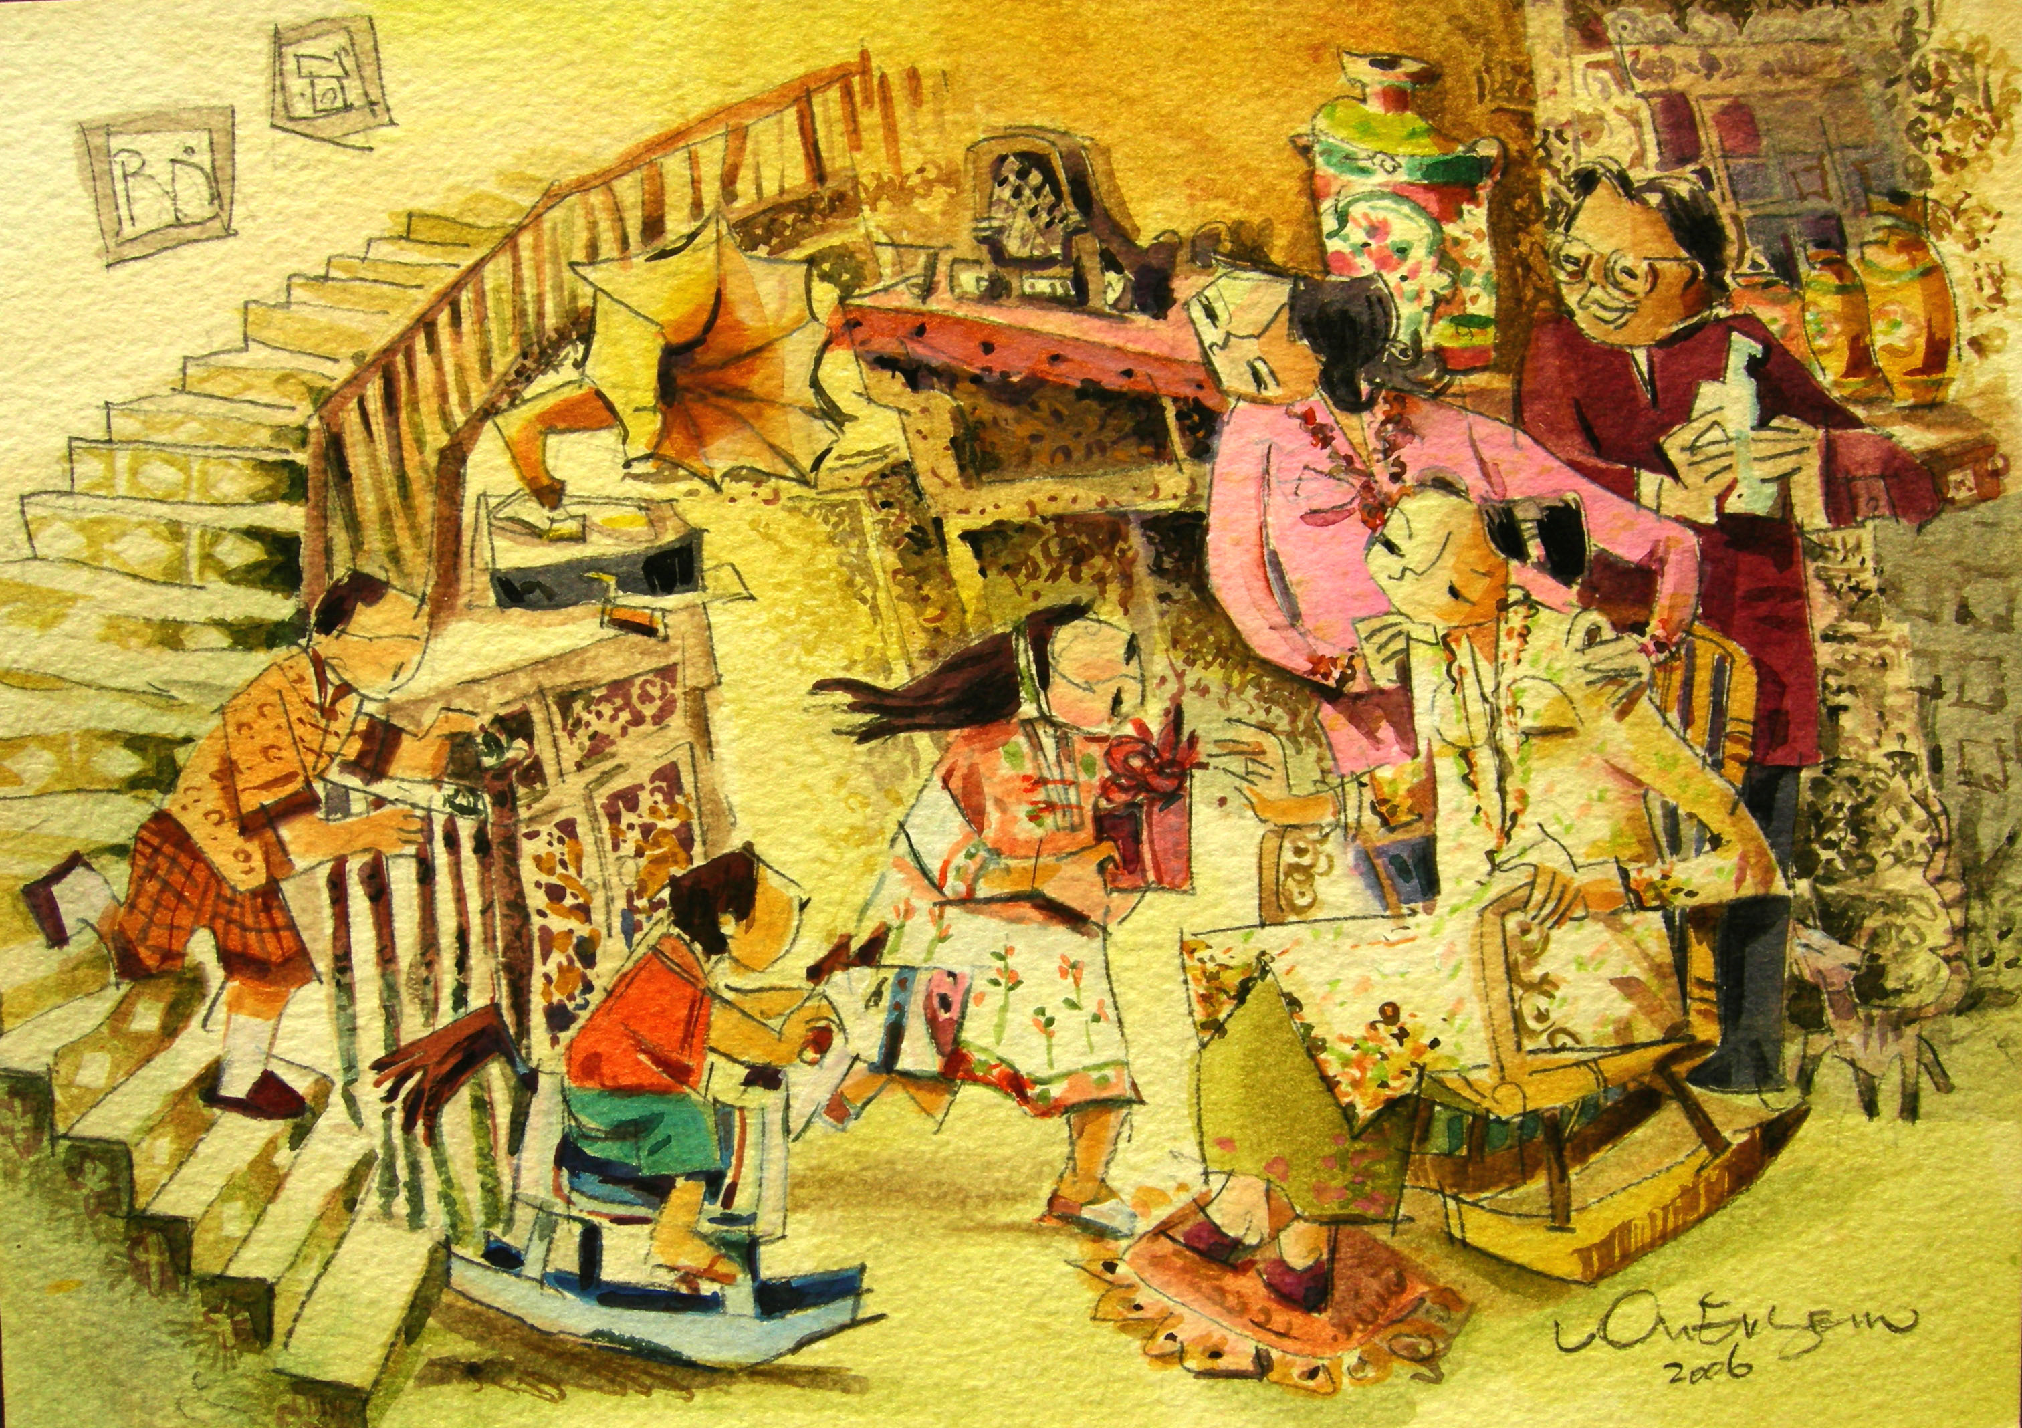
Good morning grandma
Grandma seated on a rocking-chair happily watching her grandchildren having fun. Looking on are the children’s parents.

